**National University of Computer and Emerging Sciences**

InLab

“Simple Select Queries, Joins”

Database Systems Lab **Spring 2023**

Department of Computer Science

FAST-NU, Lahore, Pakistan

FAST NU Lahore Database Systems

**Products**

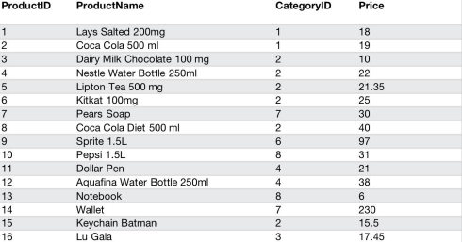

**Orders**

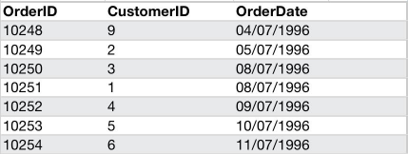Page 2

FAST NU Lahore Database Systems **Order Details**

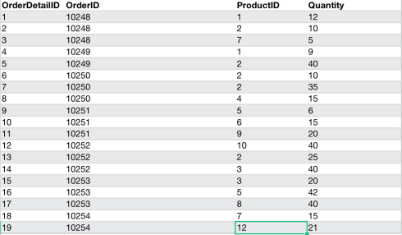

**Customers**

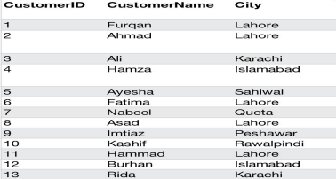

Page 3

FAST NU Lahore Database Systems

Q1. Write a SQL query to retrieve the names of all customers who have placed an order and the names of theproducts they have ordered.

Q2. Write a SQL query to retrieve the total value of all orders for each customer, along with the customer name.

Q3. Write a SQL query to retrieve the names of customers who have ordered a specific product. Q4. Write a SQL query to retrieve the names of all products that have been ordered by Ayesha.

Q5. Write a SQL query to retrieve the total number of products ordered by each customer, along with the customer name.

Q6. Write a SQL query to retrieve the total value of all orders for each customer, along with the customer name.

Q7. Write a SQL query to retrieve the total quantity of each product that has been ordered. Q8. Write a SQL query to retrieve the names of customers who have ordered more than 10 products.

Page 4